**Continuous Integration / Continuous Pipeline Lab**

**Step 1 : Creating Project on CodeStar**

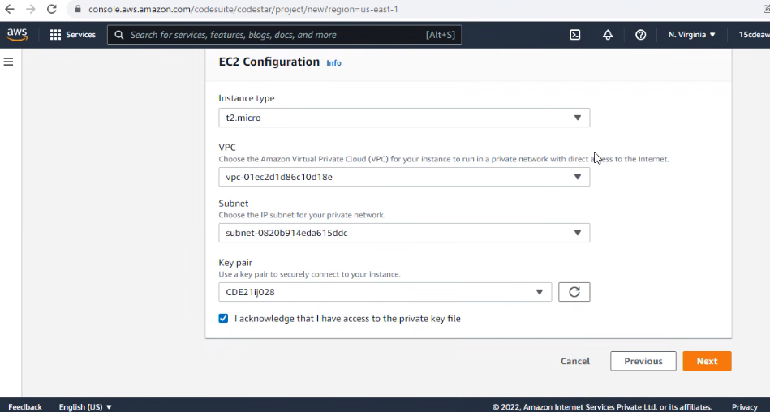

**Step 2: Provisioning Project**

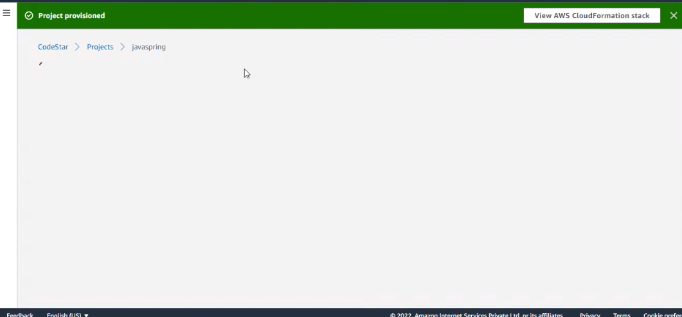

**Step 3: Configuring Amazon Cloud9 IDE.**

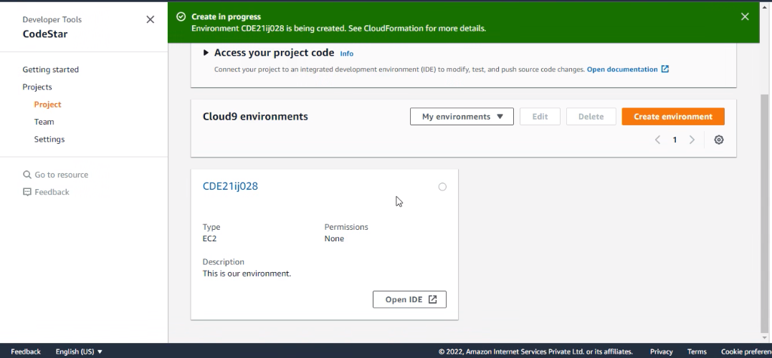

**Step 4: CICD Pipeline**

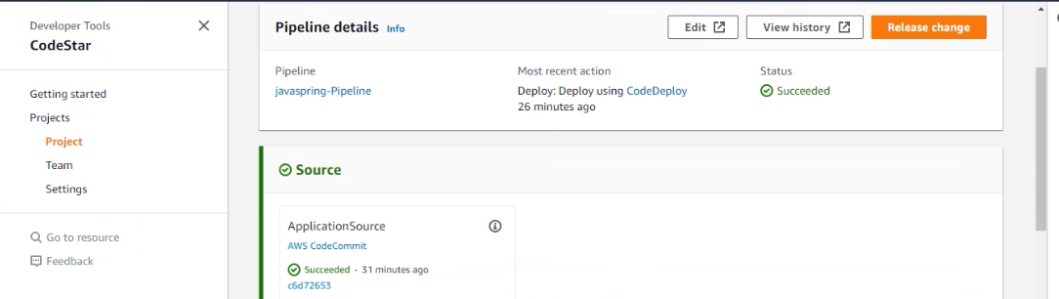

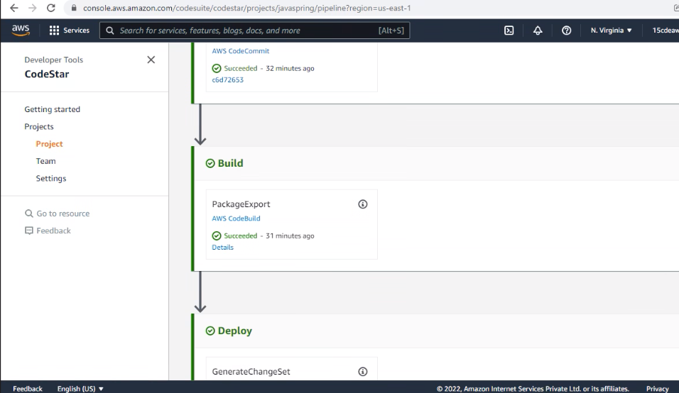

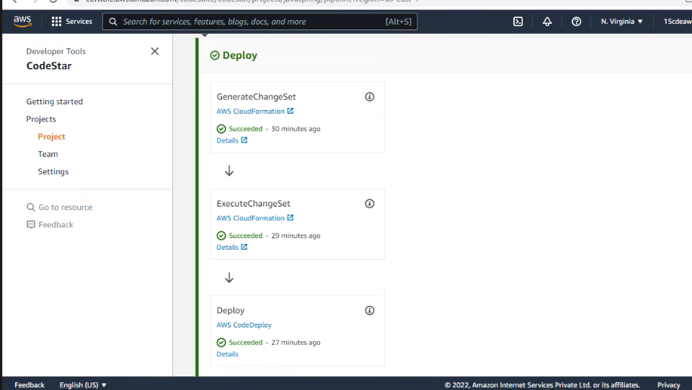

**Step 5: Launching the created spring web application on web.**

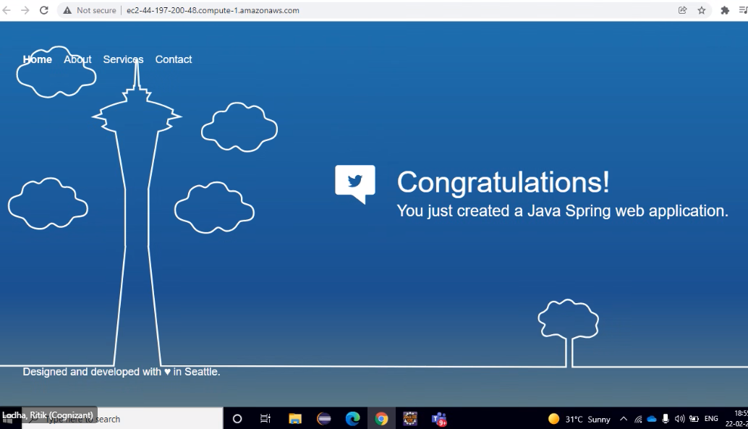

**Step 6 : Making changes in the index.jsp file.**

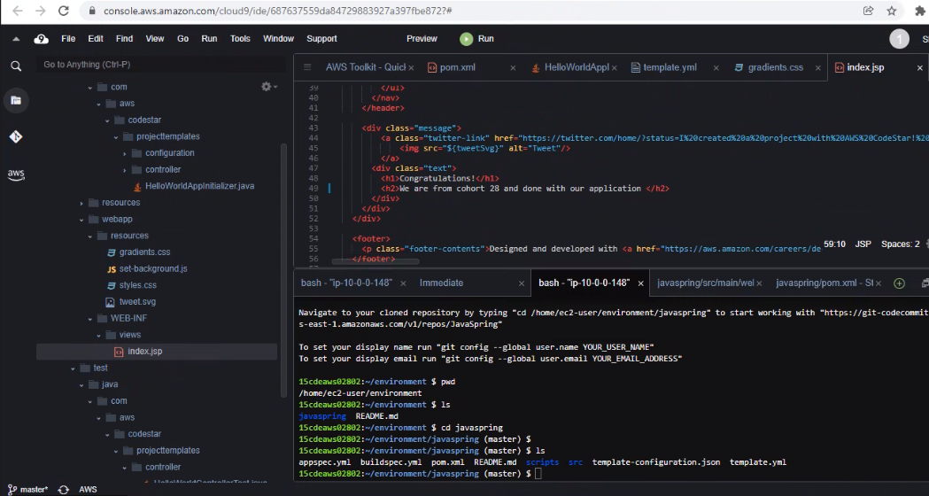

**Step 7 : Committing the saved changes to AWS Cloud Commit.**

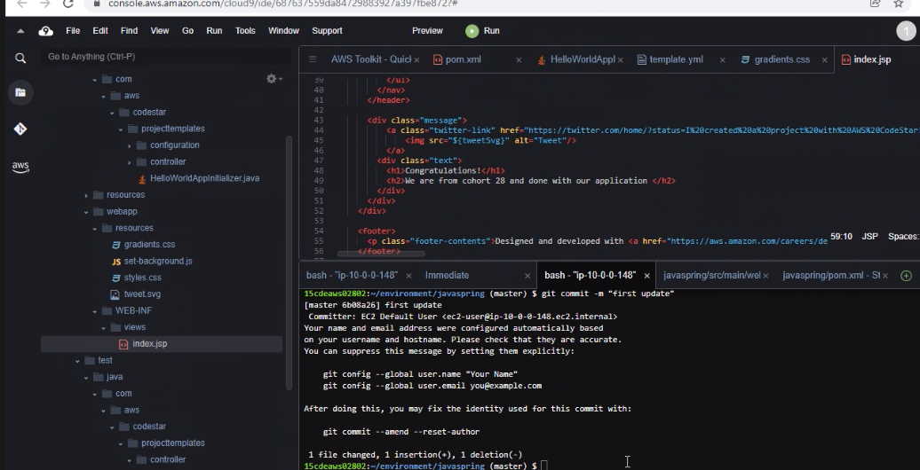

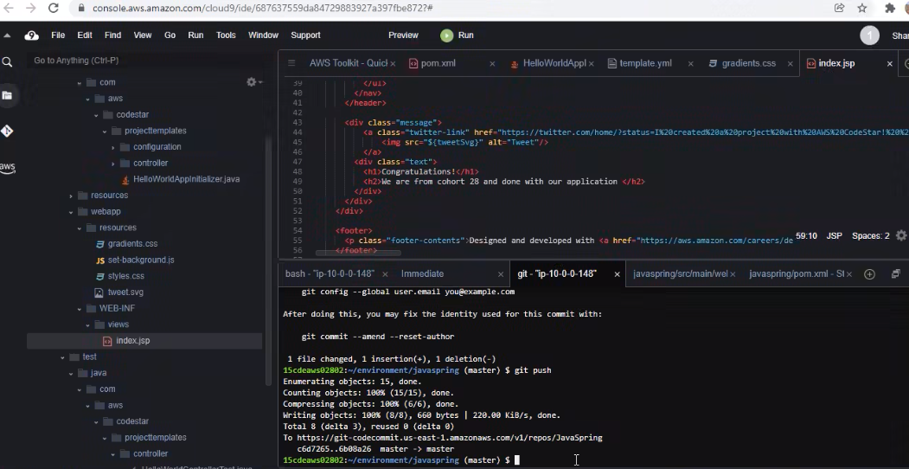

1. Again, running the application after pushing the code to the Aws Cloud Commit repository and seeing the changes.

